import numpy as np

# ----------------------------
# Part 1: 0/1 Knapsack Problem
# ----------------------------
def knapsack(profits, weights, capacity):
n = len(profits)
dp = [[0] * (capacity + 1) for _ in range(n + 1)]

# Build DP table
for i in range(1, n + 1):
for w in range(1, capacity + 1):
if weights[i-1] <= w:
dp[i][w] = max(profits[i-1] + dp[i-1][w - weights[i-1]], dp[i-1][w])
else:
dp[i][w] = dp[i-1][w]

# Backtrack to find chosen items
chosen_items = []
w = capacity
for i in range(n, 0, -1):
if dp[i][w] != dp[i-1][w]:
chosen_items.append(i-1)
w -= weights[i-1]

return dp[n][capacity], list(reversed(chosen_items))

# Example Knapsack Data
profits = [2, 4, 7, 10]
weights = [1, 3, 5, 7]
capacity = 8

max_profit, chosen = knapsack(profits, weights, capacity)
print("===== 0/1 Knapsack =====")
print("Profits:", profits)
print("Weights:", weights)
print("Capacity:", capacity)
print("Max Profit:", max_profit)
print("Chosen Items (indices):", chosen)
print("Chosen Items (profits):", [profits[i] for i in chosen])

# ----------------------------
# Part 2: Ridge Regression
# ----------------------------
def ridge_regression(X, y, lam):
"""Closed-form solution of Ridge Regression"""
n_features = X.shape[1]
w = np.linalg.inv(X.T @ X + lam * np.eye(n_features)) @ X.T @ y
return w

# Toy dataset
X = np.array([[1,1],
[1,2],
[1,3]]) # feature matrix
y = np.array([1,2,3]) # target
lam = 1 # regularization parameter

w = ridge_regression(X, y, lam)
y_pred = X @ w

print("\n===== Ridge Regression =====")
print("Optimal Parameters (w):", w)
print("Predictions:", y_pred)
print("True y:", y)

# ----------------------------
# Conceptual Link
# ----------------------------
print("\n===== Connection =====")
print("Knapsack: trade-off between profit vs weight (constraint)")
print("Ridge Regression: trade-off between error reduction vs parameter penalty (regularization)")

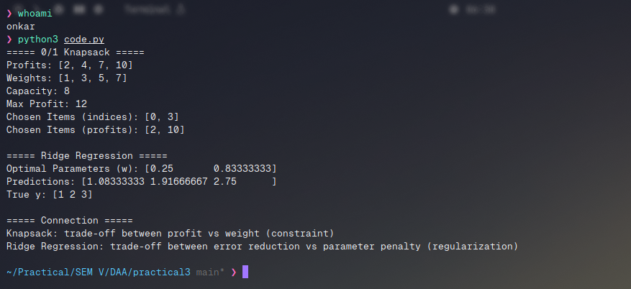
Output:

